AI Assistant lab -19.3
Name:K.Dhana sri
Batch:41
Rollno:2303a52153
Task 1 – Python to C++ Conversion
Task:
Translate a simple Python class into C++ using AI assistance. Instructions:
- Prompt AI to convert a Python class representing a Student with attributes and methods into equivalent C++ code
- Ensure proper handling of:
- Constructors
- Data types
- Access specifiers
- Compile and run both versions to verify output consistency Prompt
Convert a Python class Student with attributes name, age and a display() method into equivalent C++ code with constructor and proper access specifiers.
Python code
class Student:
def init (self, name, age): self.name = name
self.age = age

def display(self): print(self.name, self.age)

s = Student("John", 20) s.display()
C++ code
#include <iostream> using namespace std;

class Student { private:

string name; int age;

public:
Student(string n, int a) { name = n;
age = a;
}

void display() {
cout << name << " " << age << endl;
}
};

int main() {
Student s("John", 20); s.display();
return 0;
}
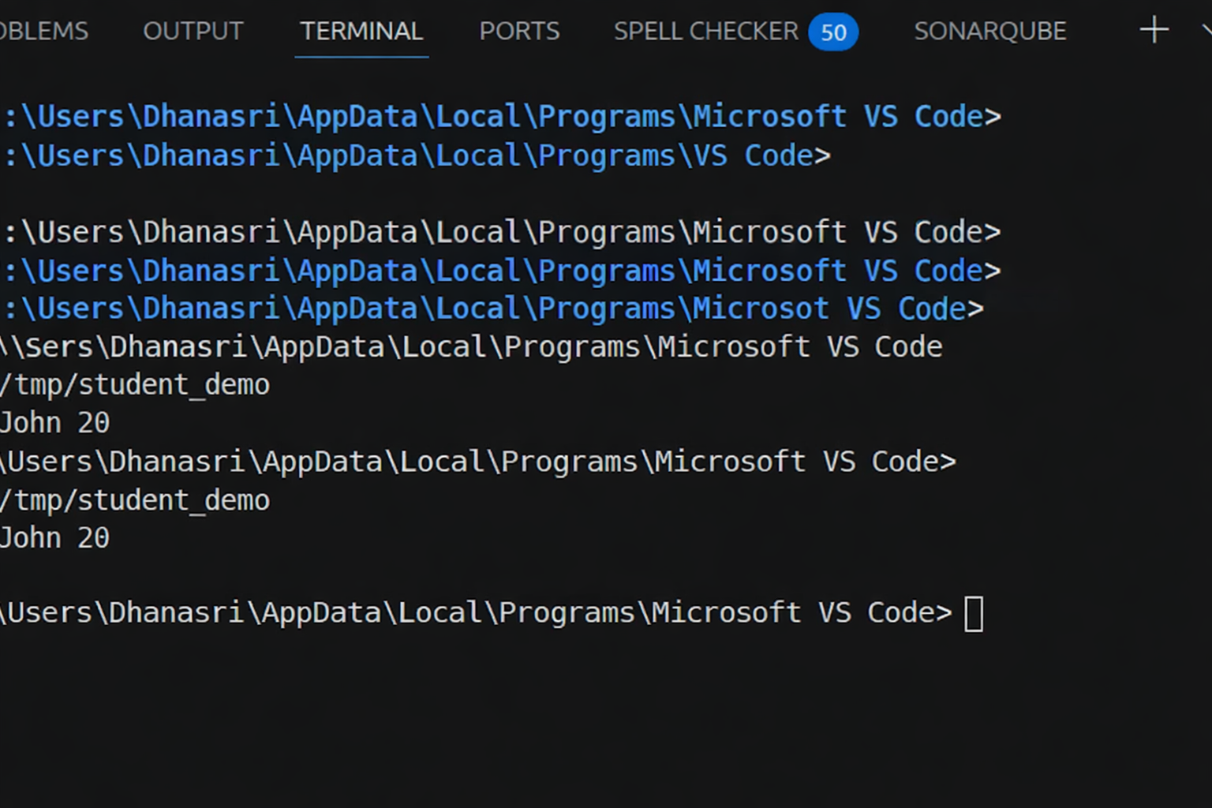
Justification

Justification
Constructor added explicitly in C++ Data types defined (string, int) Encapsulation via private/public

Task 2 – Java to Python Function Conversion
Task:
Convert a Java method that checks whether a number is prime into Python.
Instructions:
- Ask AI to translate a Java isPrime() method into Python
- Test the function with multiple inputs
- Ensure the Python version follows Pythonic syntax and logic Prompt:
Convert Java method isPrime(int n) into Python function using Pythonic syntax.
Java code
public static boolean isPrime(int n) { if(n <= 1) return false;
for(int i=2; i<=n/2; i++) {
if(n % i == 0) return false;
}
return true;
}
Python code
def is_prime(n): if n <= 1:
return False
for i in range(2, n//2 + 1): if n % i == 0:
return False return True

print(is_prime(7)) print(is_prime(10))
Output:

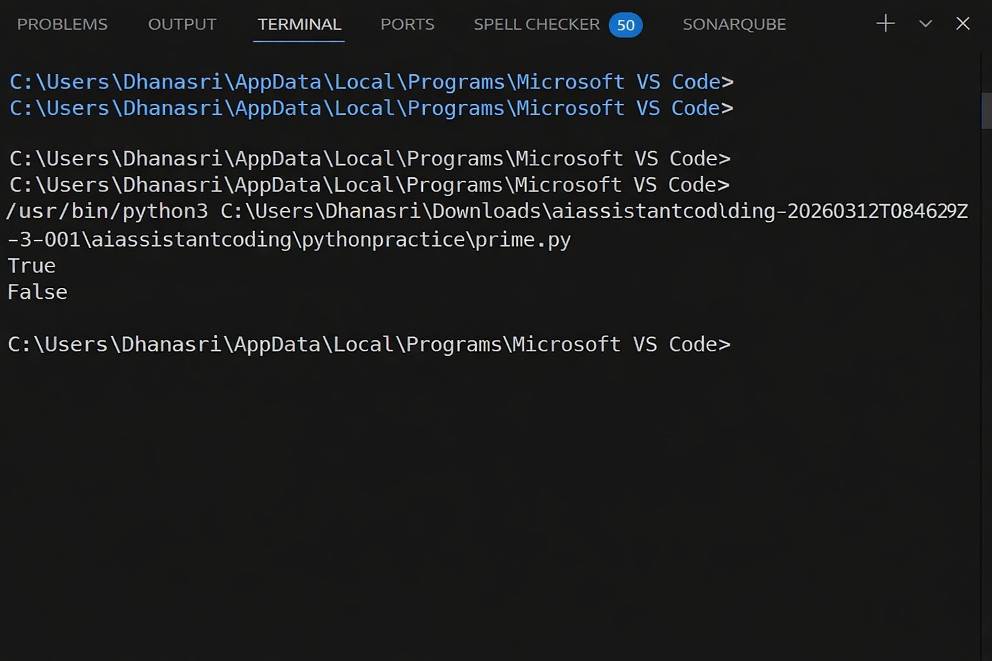
Justification:
Python uses indentation instead of braces
range() replaces loop structure Cleaner syntax (no type declaration) Logic preserved exactly

Task 3 – Pseudocode to Python Implementation
Task:
Translate a given pseudocode algorithm into Python using AI. Instructions:
- Provide AI with pseudocode for sorting numbers (e.g., bubble sort or selection sort)
- Ask AI to convert it into executable Python code
- Validate correctness using sample input lists Prompt
Convert bubble sort pseudocode into Python program. Code
def bubble_sort(arr): n = len(arr)
for i in range(n):
for j in range(0, n-i-1): if arr[j] > arr[j+1]:
arr[j], arr[j+1] = arr[j+1], arr[j]
return arr

data = [5, 2, 9, 1]
print(bubble_sort(data))
Output:

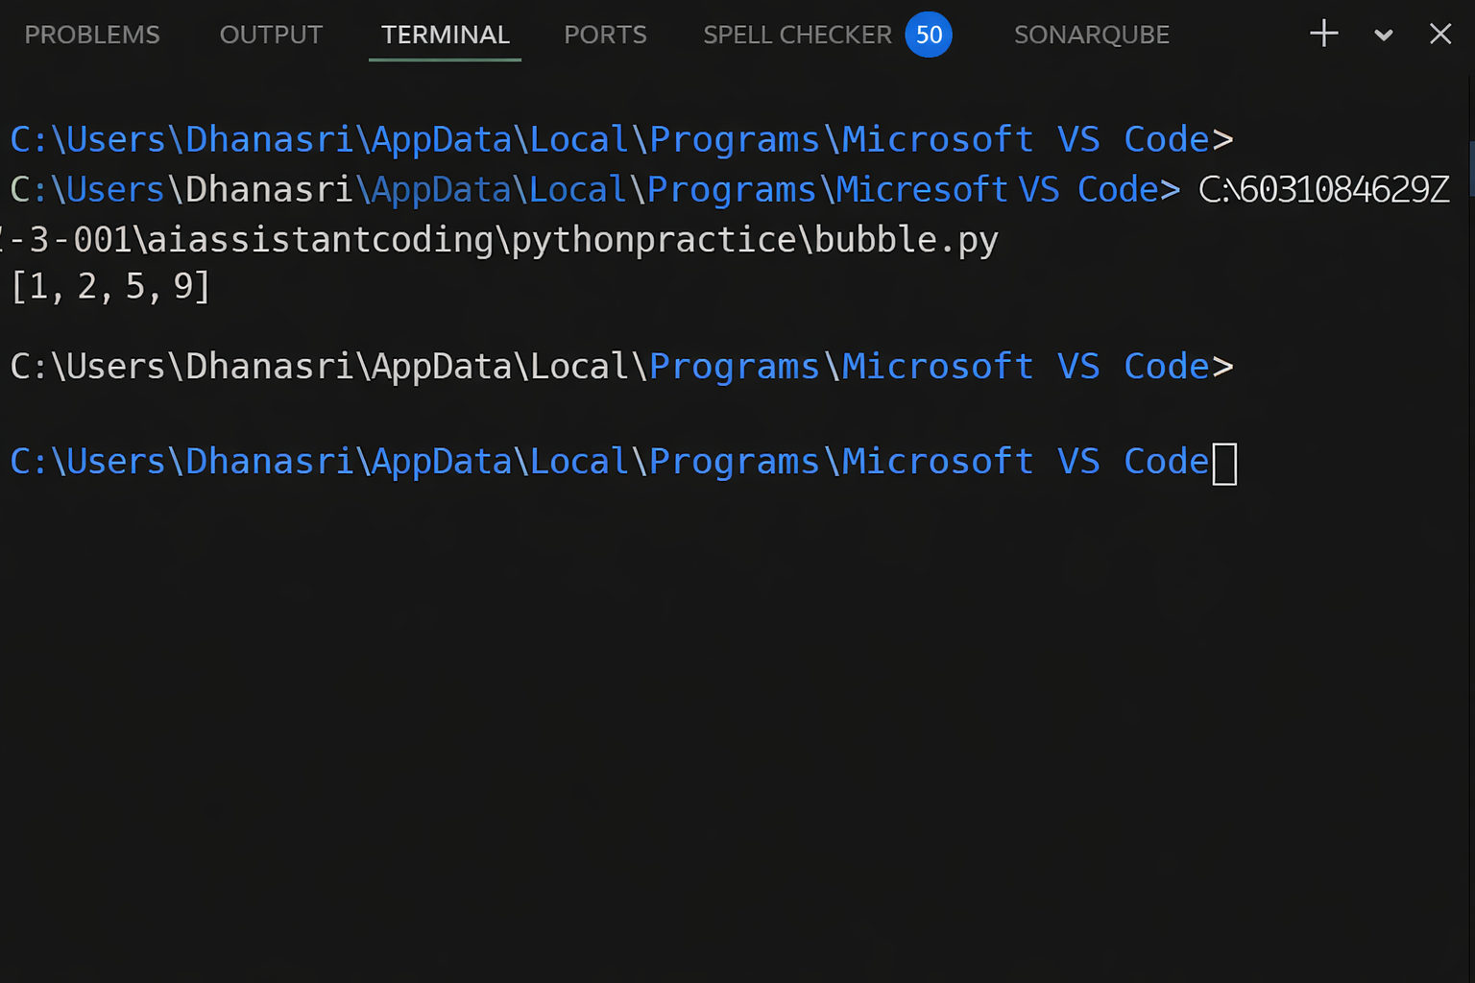

Justification:
Pseudocode loops directly mapped to Python loops Swap done using tuple unpacking
Algorithm correctness verified Task 4 – SQL to Pandas Query Task:
Translate a SQL query into a Pandas DataFrame operation in Python.
Instructions:
- Provide AI with a SQL query (e.g., SELECT name, salary FROM employees WHERE salary > 50000).
- Ask AI to generate equivalent Pandas code.
- Test the generated code on a sample DataFrame Prompt:
Convert SQL query SELECT name, salary FROM employees WHERE salary > 50000 into Pandas code.
Code
Sql query
ELECT name, salary FROM employees
WHERE salary > 50000;
Python pandas code
import pandas as pd

data = {
"name": ["A", "B", "C"], "salary": [40000, 60000, 70000]
}

df = pd.DataFrame(data)

result = df[df["salary"] > 50000][["name", "salary"]] print(result)
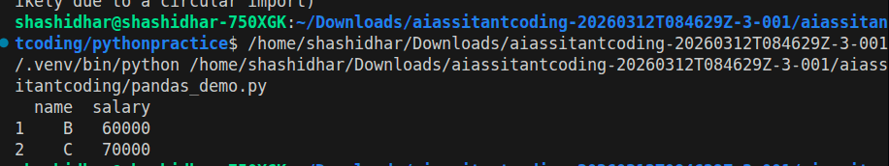
Output:

Justification
WHERE → Boolean filtering SELECT → column selection Equivalent data subset returned

Task 5 – Real-Time Application: Algorithm Translation Across
Languages Scenario:
A company maintains algorithms written in different programming languages.
Examples:
- Converting a Python searching algorithm into C
- Translating a Java sorting program into JavaScript Instructions:

- Use AI to translate a selected algorithm between two programming languages
- Execute and test both versions
- Document translation challenges such as:
- Syntax differences
- Library support
- Memory management Prompt
Convert Python linear search algorithm into C language with proper memory handling.
Code
def search(arr, key):

for i in range(len(arr)): if arr[i] == key:
return i return -1

print(search([1,2,3,4], 3))
C code
#include <stdio.h>

int search(int arr[], int n, int key) { for(int i = 0; i < n; i++) {
if(arr[i] == key) return i;
}

return -1;

}

int main() {

int arr[] = {1,2,3,4};

int result = search(arr, 4, 3); printf("%d\n", result);
return 0;

}
Output:
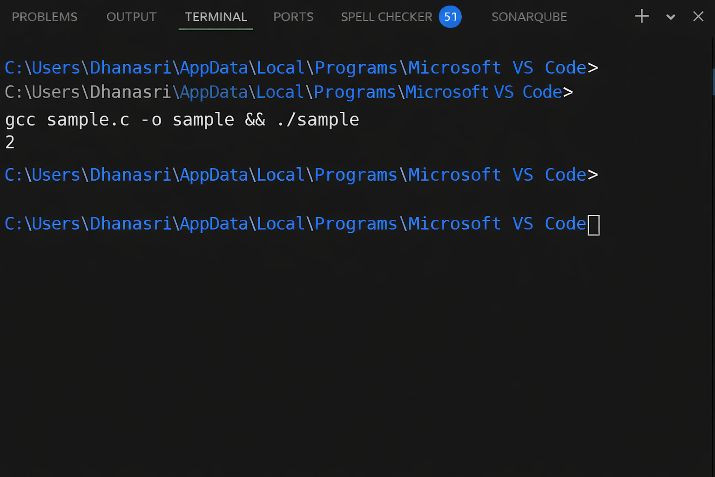

Justification
Manual array handling in C
No dynamic typing → explicit sizes required

Memory handled via static arrays Same logic preserved

